Bowler Award Order Form
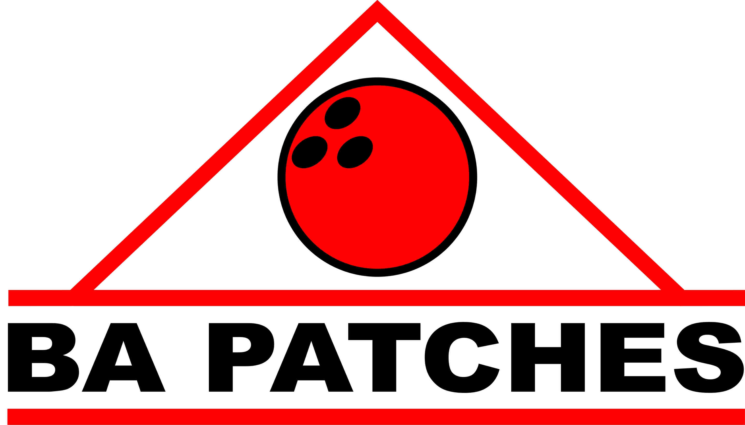

Name: ________________________________________________________________________________

Ship to Address: __________________________________________________________________ ______

City: ___________________________________ Apt: _________ State: __________________________

Zip Code: _____________ Phone: ___________________________ Best Time to Call ________________

Email Address: __________________________________________________________________________

Game Qty Series Qty Special Effort Qty
160 _____ 300 ____ All Spare Game ____
175 _____ 400 ____ Triplicate ____
180 _____ 500 ____ Big 4 (4-6-7-10) ____
200 _____ 600 ____ 7-10 Split ____
225 _____ 700 ____ Dutch 200 ____
250 _____ 800 ____ No Tap 300 ____
275 _____ 75 Pins Ov Avg ____
300 _____ 100 Pins Ov Avg ____
*We can make any score for game 150 Pins Ov Avg ____
Sour Apple (5-7-10) ____
Step Ladder Games ____
League High Avg ____
League Champion ____

Name to be placed on patch: _______________________________________
(Association, club name, bowling center or league)

Color for Name: (Circle one) Red Yellow Blue Black

Special Instructions or request: _______________________________________________________________

________________________________________________________________________________________

Customer signature to authorize: _______________________________________________

PLEASE be sure to provide your telephone number so we can quote you a firm price.
Any questions please call 775-751-0340 or email uccexpress2017@gmail.com.

Payment will be made to UCC-Express, Inc. Mail to: 1641 E. Dollar St., Pahrump, NV 89048
Sales Tax applies in Nevada. Please add your county tax rate to total sale price. Free shipping!

